Understanding Data Relationships in MS Access

Diving into the details of relationships in MS Access

By
Muhammad Saad khan
24K-0680
BCS-1K

Table of Contents
1. INTRODUCTION 3
1.1 ONE-TO-ONE RELATIONSHIP 3
1.2 ONE-TO-MANY RELATIONSHIP 3
1.3 MANY-TO-MANY RELATIONSHIP 3
2. HOW RELATIONSHIPS ARE ESTABLISHED 4
3. IMPORTANCE OF REFERENTIAL INTEGRITY 7

1. INTRODUCTION

1.1 ONE-TO-ONE RELATIONSHIP
In MS Access, a One-to-One relationship is a type of relationship where each record in a table corresponds to only one record of another table. This relationship is used to separate data for efficiency and security. For example, a table titled Employees can contain general information of the employees whereas a table titled Employee Details can store sensitive information such as login credentials. This type of relationship is established by linking the primary key of both tables and making sure that no record in either table relates to more than one record in the other table.

1.2 ONE-TO-MANY RELATIONSHIP
The One-to-Many relationship in MS Access is perhaps the most used relationship. It is used when a single record in a table corresponds to multiple records in another table. For example, a record in Customers table can be related to multiple records in the Orders table, as customers can place many orders. The primary key in the Customers table (which can be Customers ID) is linked to a foreign key in the Orders table (Customers ID in this case) while also ensuring data integrity.

1.3 MANY-TO-MANY RELATIONSHIP
In MS Access, the Many-To-Many relationship is used when multiple records in a table corresponds to multiple records in another table. A junction table is used in MS Access that links the two tables (Students and Courses in our given lab question assignment). The junction table (Enrollment table in our case) contains the foreign keys from both tables (Student ID & Course ID in our case), which allows each student to enroll in multiple courses and each course to have multiple students. This relationship simplifies managing complex data without duplicating data numerous times.

2. HOW RELATIONSHIPS ARE ESTABLISHED
- First, create 2 different tables that includes records (create a 3rd one, which will serve as a junction table, if you want to establish a many-to-many relationship).
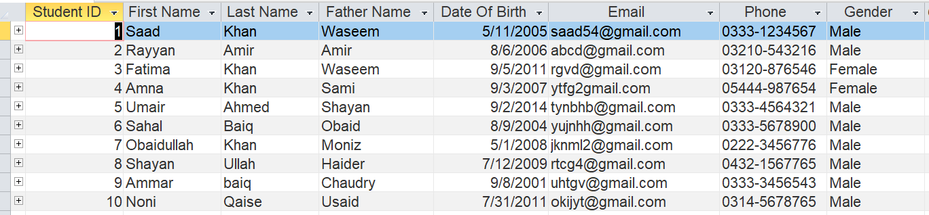

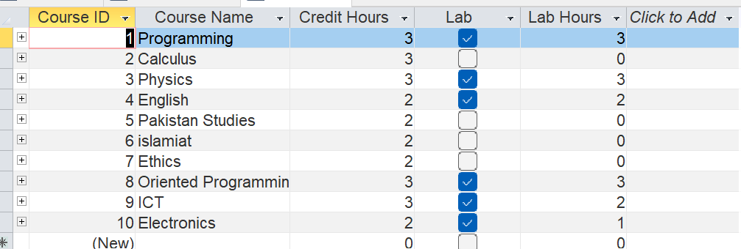
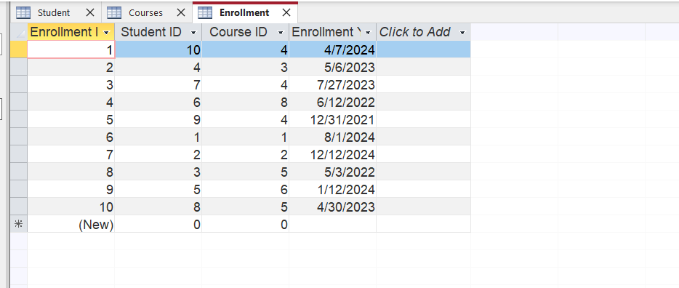
- Next, under Database Tools tab, select Relationships
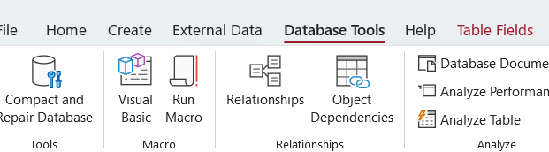

- Select and add all the tables (3 tables in our case) to the relationship sheet
- For Students table, select Student ID (primary key) and link it with the Student ID (foreign key).

- A Relationships tab will open which looks like this

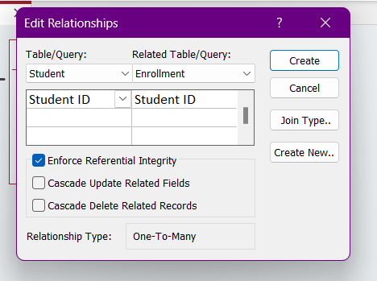

- Select the “Enforce Referential Integrity” for a Many-To-Many relationship.
- Your relationship should look like this
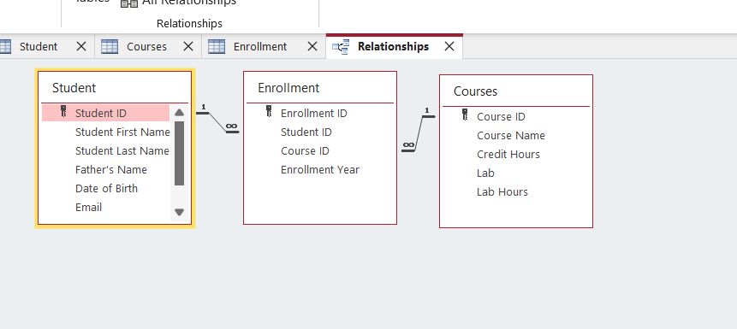

3. IMPORTANCE OF REFERENTIAL INTEGRITY
Referential integrity is vital in maintaining consistency and accurate data, especially in our Student, Courses & Enrollment example, as it ensures that the relationships formed between these tables are valid. It prevents orphaned records by ensuring that each record in the Enrollment table is linked to valid records in Student and Courses tables. For instance, if a student is deleted from the database, referential integrity prevents the deletion if the student has active enrollments, preventing the Enrollment table from displaying non-existent students or courses. It also maintains data accuracy by ensuring that invalid data cannot be entered. For example, when adding a new enrollment record, referential integrity verifies that the Student ID and Course ID in the Enrollments table matches with the records in the Student and Courses tables. Referential integrity also keeps data consistent by updating data accordingly. For example, if a Student ID is updated in the Student table, it updates the data in all related records in the Enrollment table, managing the synchronization of data across all tables.

